**SARLA CHOPRA DAV PUBLIC SCHOOL SECTOR-56 NOIDA**



**COMPUTER SCIENCE PROJECT FILE**

**ACADEMIC YEAR 2018-19**

**C++ PROJECT ON**

**BANK MANAGEMENT SYSTEM**

**PREPARED BY: RITISHA SINGH**

**CLASS: XII ‘A’**

**CONTENTS**

**TITLE PAGE NO.**

**CERTIFICATE 1**

**ACKNOWLEDGEMENTS 2**

**INTRODUCTION 3**

**REQUIREMENTS 4**

**HEADER FILES USED 5**

**SOURCE CODE 6**

**OUTPUTS 17**

**BIBLIOGRAPHY 24**

**CERTIFICATE**

This is to certify that RITISHA SINGH of class XII-A has completed the project work under my guidance titled “Bank Management System”.

The report is the result of his efforts and perseverance.

The report is found worthy of acceptance as the final project report for computer science subject of class XII.

# SHALINI SHARMA

# COMPUTER SCIENCE

# SARLA CHOPRA DAV PUBLIC SCHOOL

# SECTOR-56 NOIDA

**ACKNOWLEDGEMENT**

I would like to thank GOD, who gave me strength and will to complete my tasks in successful transition.

I wish to express my sincere thanks to Mrs IP Bhatia Principle DAV Noida sector-56 NOIDA for guiding me to cause the successful outcome of this project work.

I wish to express my deep and profound sense of gratitude to our guide teacher Mrs Shalini Sharma for her expert help and valuable guidance, comments and suggestions.

I also place record, our sincere gratitude to one and all who directly or indirectly lent their interests in the success of this venture.

20.11.2018 **(Ritisha singh)**

**INTRODUCTION**

The prepared project processes the stored data under some specific commands. A data file is created to store the account details and some quick information about it and allows the user to access it.

The user can open a new bank account, withdraw or deposit in an existing account, check the balance, display all account holder’s list, delete an account and modify an account.

The system will give basic information for a bank account. The project consists of a class named bank having data members like account name, user name, account type, etc. It also has various functions to perform the desirable tasks.

Hence this project will help in various fields in practical use.

**REQUIREMENTS**

HARDWARE:

* + Printer

(For printing the hard copy of the report file)

* + Compact Disc

(For storing the executable file of the project)

* + 4GB RAM
  + 64 bit processor
  + Windows 8.1 pro

SOFTWARE:

* + Turbo C++

(Basic software for developing the project in C++)

* + MS Word

(For representing the soft copy of the file)

**HEADER FILES USED**

#include<fstream.h>

FOR USING THE CONCEPT OF DATA FILE HANDLING FOR STORING DATA

#include<conio.h>

FOR USING CLRSCR() AND GETCH() FUNCTIONS FOR BETTER DISPLAY OF SCREENS

#include<stdio.h>

FOR USING GETS() AND PUTS() FUNCTIONS FOR INPUTTING STRING VALUES FOR PROCESSING.

#include<string.h>FOR USING ALL THE STRING FUNCTIONS FOR STRING PROCESSING.

**SOURCE CODE**

#include<fstream.h>

#include<conio.h>

#include<string.h>

#include<stdio.h>

class bank

{

int acc_no;

char name[50];

int amt;

char acc_type;

char bank_nm[20];

int dep;

public:

bank()

{ acc_no=123;

strcpy(name,"ABC");

strcpy(bank_nm,"XYZ");

acc_type='NA';

amt=0;

}

void disp_acc();

void create_acc();

void modify();

void deposit(int);

void draw(int);

int ret_acc();

int ret_dep();

char ret_acctype();

};

void bank::create_acc()

{ cout<<"\n ENTER BANK NAME:";

gets(bank_nm);

cout<<"\t \t \t WELCOME TO "<<bank_nm<<" BANK";

cout<<"\n ENTER ACCOUNT NO: ";

cin>>acc_no;

cout<<"\n ENTER YOUR NAME: ";

gets(name);

cout<<"\n ENTER YOUR ACCOUNT TYPE( C FOR CURRENT/S FOR SAVINGS): ";

cin>>acc_type;

cout<<"\n ENTER AMOUNT TO BE DEPOSITED(>5000)" ;

cin>>amt;

cout<<"\n ACCOUNT CREATED ";

}

void bank::disp_acc()

{ cout<<"\n BANK NAME:"<<bank_nm<<":";

cout<<"\n ACCOUNT NO:"<<acc_no;

cout<<"\n NAME:"<<name;

cout<<"\n ACCOUNT TYPE:";

if(acc_type=='C')

cout<<"CURRENT";

else if(acc_type=='S')

cout<<"SAVINGS";

cout<<"\n BALANCE="<<amt;

cout<<"\n";

}

void bank::modify()

{ cout<<"\n ENTER NEW BANK NAME: ";

gets(bank_nm);

cout<<"\t \t \t WELCOME TO "<<bank_nm<<" BANK";

cout<<"\n ENTER NEW ACCOUNT NO: ";

cin>>acc_no;

cout<<"\n ENTER NEW NAME: ";

gets(name);

cout<<"\n ENTER YOUR ACCOUNT TYPE( C FOR CURRENT/S FOR SAVINGS): ";

cin>>acc_type;

cout<<"\n ENTER AMOUNT TO BE DEPOSITED(>5000)" ;

cin>>amt;

}

void bank::deposit(int x)

{ amt+=x;

cout<<"\n AMOUNT SUCCESSFULLY DEPOSITED: ";

}

void bank::draw(int x)

{ amt-=x;

cout<<"\n AMOUNT SUCCESSFULLY WITHRAWN: ";

}

int bank::ret_acc()

{ return acc_no;

}

int bank::ret_dep()

{ return amt;

}

char bank::ret_acctype()

{ return acc_type;

}

void write_acc()

{ bank bn;

ofstream fout;

fout.open("banking.dat",ios::binary|ios::app);

bn.create_acc();

fout.write( (char*) &bn,sizeof(bn) );

fout.close();

}

void spdisp_acc(int n)

{ bank bn;

int flag=0;

ifstream fin;

fin.open("banking.dat",ios::binary|ios::in);

fin.read( (char*) &bn,sizeof(bn) );

while(!fin.eof() )

{ if(bn.ret_acc()==n){

flag=1;

bn.disp_acc();

}

fin.read( (char*) &bn,sizeof(bn) );

}

if(flag==0)

cout<<"\n ACCOUNT DOES NOT EXIST: ";

fin.close();

}

void all_acc()

{ bank bn;

ifstream fin;

fin.open("banking.dat",ios::binary|ios::in);

fin.read( (char*) &bn,sizeof(bn) );

cout<<"\n \n \n ACCOUNT HOLDER'S LIST ";

while(!fin.eof())

{ bn.disp_acc();

fin.read( (char*) &bn,sizeof(bn) );

}

fin.close();

}

void depdraw(int n)

{ bank bn;

ifstream fin;

fin.open("banking.dat",ios::binary|ios::in);

fin.read( (char*) &bn,sizeof(bn) );

while(!fin.eof() )

{ int choice;

float amount=0;

if(bn.ret_acc()==n)

{ cout<<"\n ENTER YOUR CHOICE: ";

cout<<"\n 1:DEPOSIT \n 2:WITHDRAW \n";

cin>>choice;

if(choice==1)

{ cout<<"\n ENTER AMOUNT TO BE DEPOSITED: ";

cin>>amount;

bn.deposit(amount);}

else if(choice==2)

{ cout<<"\n ENTER AMOUNT TO BE WITHDRAWN: ";

cin>>amount;

if(amount>bn.ret_dep() )

cout<<"\n INSUFFICIENT BALANCE: ";

else

bn.draw(amount);

}

else

cout<<"\n ACCOUNT DOES NOT EXIST: ";

}

fin.read( (char*) &bn,sizeof(bn) );

}

fin.close();

}

void delete_acc(int n, int silent=0)

{ bank bn;

ofstream fout;

fout.open("banking1.dat",ios::binary|ios::out);

ifstream fin;

fin.open("banking.dat",ios::binary|ios::in);

fin.read( (char*) &bn,sizeof(bn) );

//int flag=0;

while(!fin.eof() ){

if(bn.ret_acc()!=n){

//flag=1;

fout.write( (char*) &bn, sizeof(bn) );

}

fin.read( (char*) &bn,sizeof(bn) );

}

//if(flag==0 && silent!=1)

// cout<<"\n ACCOUNT DOES NOT EXIST: ";

fin.close();

fout.close();

remove("banking.dat");

rename("banking1.dat","banking.dat");

if(silent!=1)

cout<<"\n ACCOUNT SUCCESSFULLY DELTED" ;

}

void modify_acc(int n )

{

bank bn;

int flag=0;

ifstream fin;

fin.open("banking.dat",ios::binary|ios::in);

fin.read( (char*) &bn,sizeof(bn) );

while(!fin.eof() )

{ if(bn.ret_acc()==n){

flag=1;

bn.disp_acc();

break;

}

fin.read( (char*) &bn,sizeof(bn) );

}

if(flag==0)

cout<<"\n ACCOUNT DOES NOT EXIST: ";

else{

bn.modify();

fin.close();

delete_acc(n,1);

ofstream fout;

fout.open("banking.dat",ios::binary|ios::app);

fout.write( (char*) &bn,sizeof(bn) );

fout.close();

cout << "Account modified successfully" << endl;

}

}

void intro()

{ cout<<"\n";

cout<<"\n\n\t\t\t BANK MANAGEMENT SYSTEM ";

cout<<"\n\n\t\t\t PRESS ANY KEY ";

cout<<"\n\n\n\n\n\n\n\n ";

getch();

}

void main()

{ char ch;

int num;

clrscr();

intro();

do

{ clrscr();

cout<<"\n MAIN MENU";

cout<<"\n 01. NEW ACCOUNT";

cout<<"\n 02. DEPOSIT AMOUNT";

cout<<"\n 03. WITHDRAW AMOUNT";

cout<<"\n 04. BALANCE AMOUNT";

cout<<"\n 05. ALL ACCOUNT HOLDER LIST";

cout<<"\n 06. CLOSE AN ACCOUNT";

cout<<"\n 07. MODIFY AN ACCOUNT";

cout<<"\n 08. EXIT";

cout<<"\n SELECT YOUR OPTION(1-8): ";

cin>>ch;

switch(ch)

{ case '1' :

write_acc();

break;

case '2' :

cout<<"\n\n\t ENTER ACCOUNT NO: ";cin>>num;

depdraw(num);

break;

case '3' :

cout<<"\n\n\t ENTER ACCOUNT NO: ";cin>>num;

depdraw(num);

break;

case '4':

cout<<"\n\n\t ENTER ACCOUNT NO: ";cin>>num;

spdisp_acc(num);

break;

case '5':

all_acc();

break;

case '6':

cout<<"\n\n\t ENTER ACCOUNT NO: ";cin>>num;

delete_acc(num);

break;

case '7':

cout<<"\n\n\t ENTER ACCOUNT NO: ";cin>>num;

modify_acc(num);

break;

case '8':

cout<<"\n\n\tTHANKS FOR USING BANK MANAGEMENT SYSTEM \n \n";

cout<<"\n\t\t\tSEE YOU SOON";

break;

default:cout<<"\n WRONG CHOICE";

}

getch();

}while(ch!='8');}

***OUTPUT SCREENS-***

**1.WELCOME SCREEN**

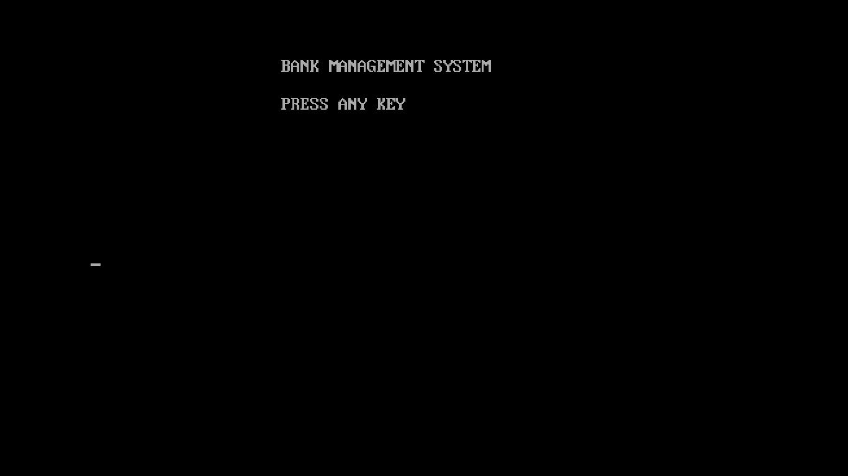

**2.MAIN MENU**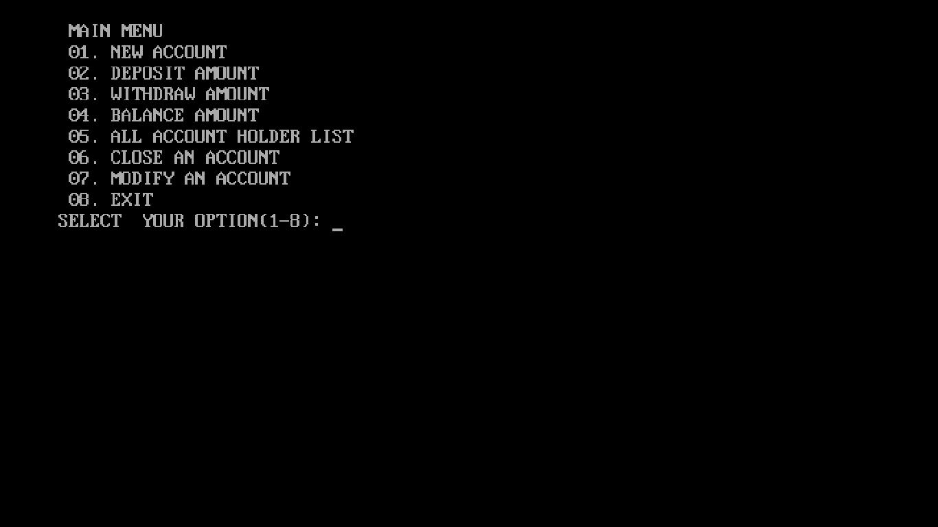

**3.OPENING AN ACCOUNT**

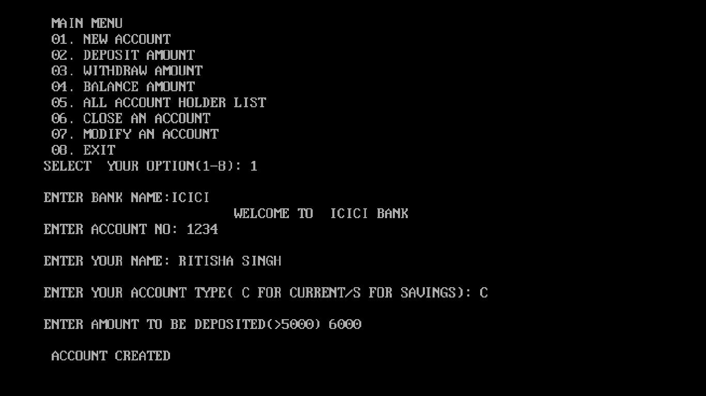

**4.DEPOSITING MONEY**

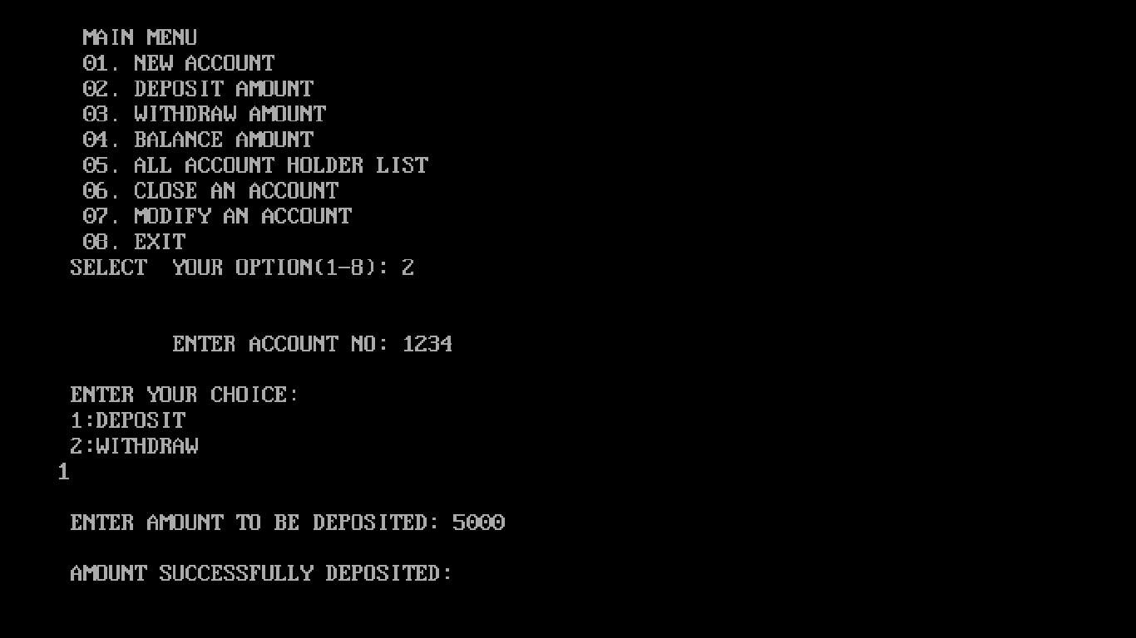

**5.WITHDRAWING MONEY**

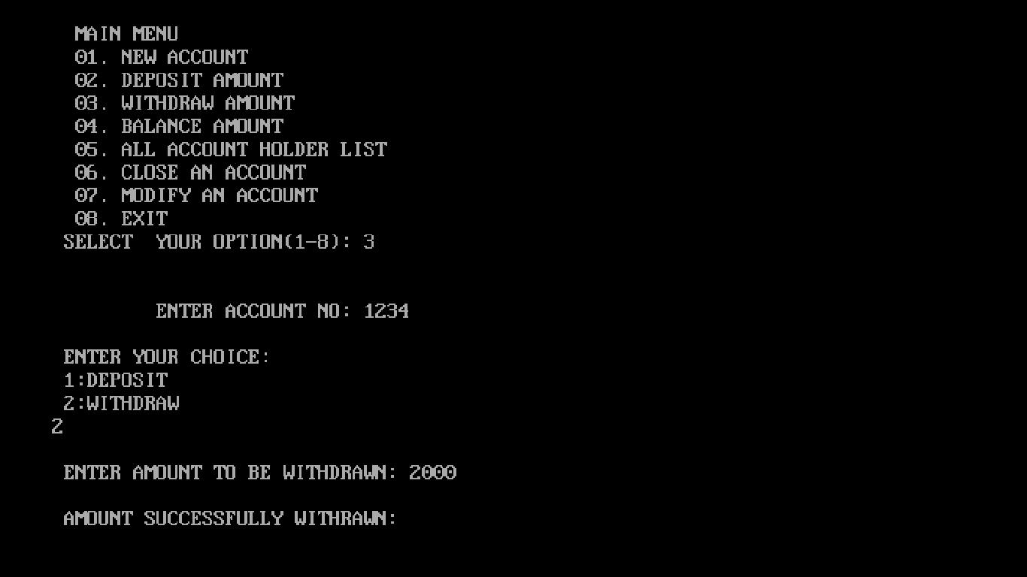

**6.CHECKING BALANCE**

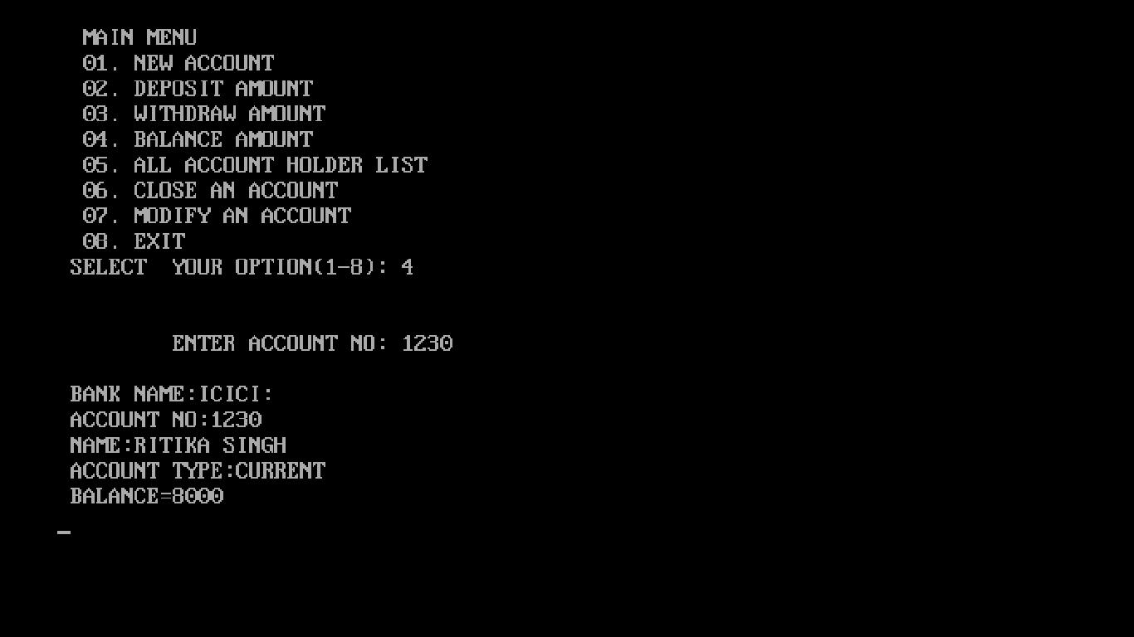

**7.GETTING LIST OF ALL ACCOUNT HOLDER’S**

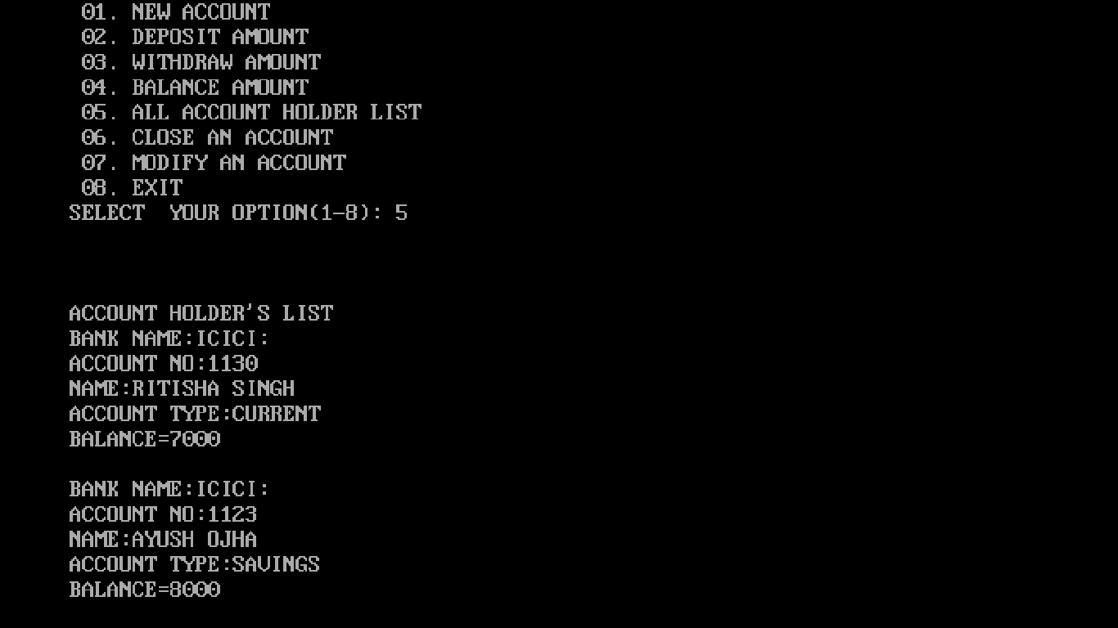

**8.DELETING AN ACCOUNT**

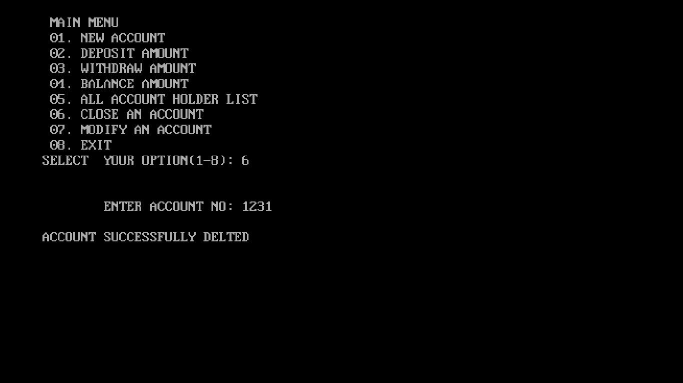

**9. EXITING FROM PROGRAM**

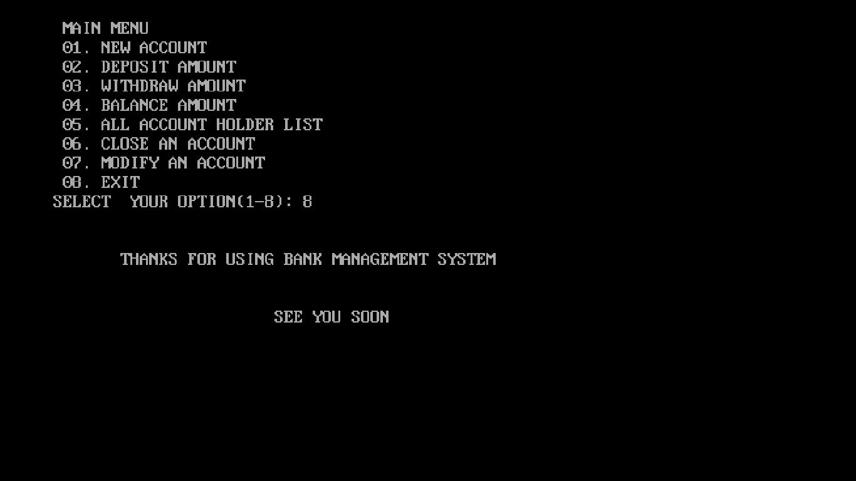

***BIBLIOGRAPHY***

**BOOKS SUMITA ARORA – COMPUTER SCIENCE WITH C++**

**WEBSITES:** [**HTTP://STACKOVERFLOW.COM/**](http://stackoverflow.com/)

[**HTTP://WWW.CPLUSPLUS.COM/**](http://www.cplusplus.com/)